**Corporate~Connection~Game**  
  
1  
  
 

2  
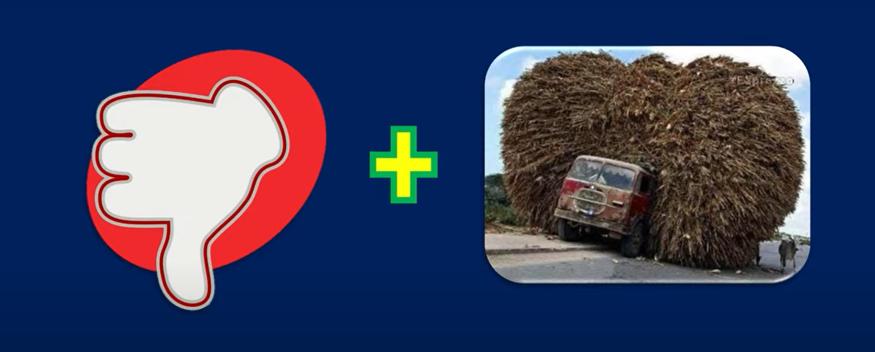

3-  
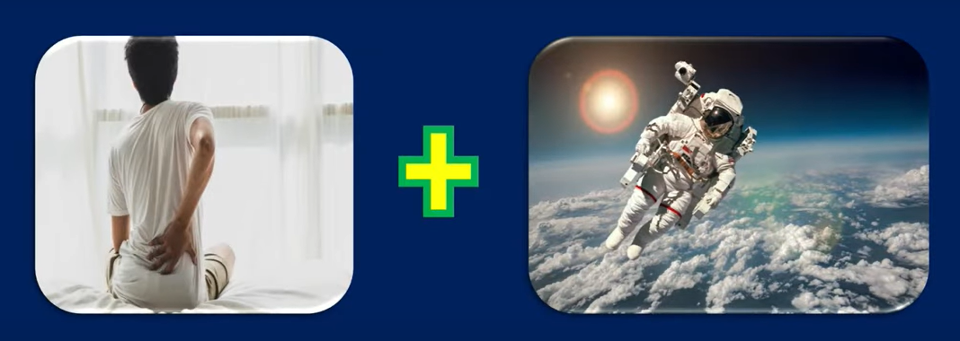

4-  
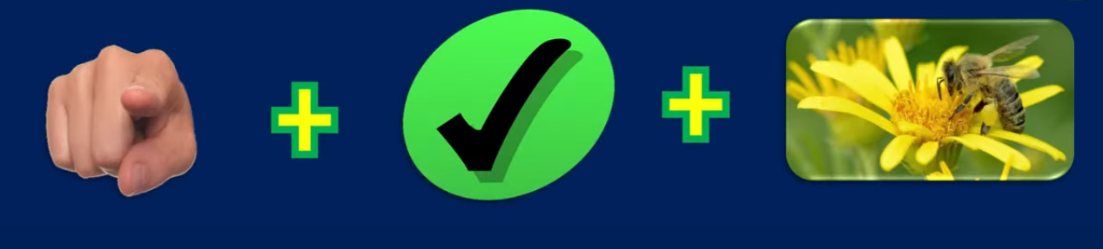  
  
  
  
  
  
  
  
  
  
  
  
  
  
  
  
  
  
  
  
  
  
  
  
  
  
  
  
  
  
  
  
  
  
  
  
  
  
  
  
  
  
  
  
5-  
  
  
  
  
  
  
  
  
  
  
  
  
  
  
  
  
  
  
  
  
  
  
  
  
  
  
  
  
  
  
  
  
  
  
  
  
  
  
  
  
6-  
  
  
  
  
  
  
  
  
  
  
  
  
  
  
  
  
  
  
  
  
  
  
  
  
  
  
  
  
  
  
  
  
  
  
  
  
  
  
  
7-  
  
  
  
  
  
  
  
  
  
  
  
  
  
  
  
  
  
  
  
  
  
  
  
  
  
  
  
  
  
  
  
  
  
  
  
  
8  
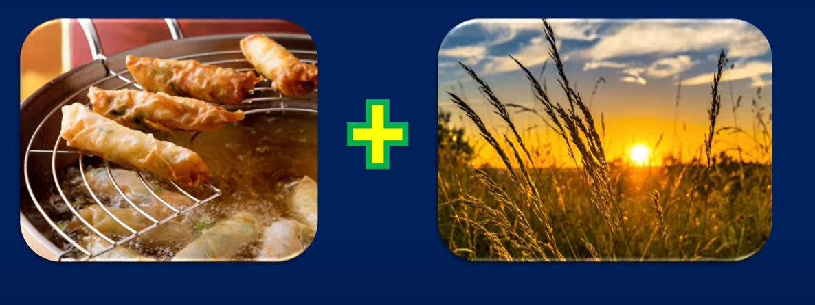  
  
  
  
  
  
  
  
  
  
  
  
  
  
  
  
  
  
  
  
  
  
  
  
  
  
  
  
  
  
  
  
  
  
  
  
  
  
  
9  
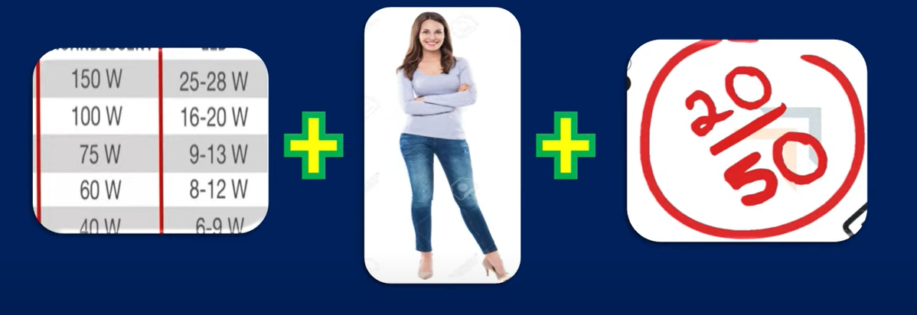  
  
  
  
  
  
  
  
  
  
  
  
  
  
  
  
  
  
  
  
  
  
  
  
  
  
  
  
  
  
  
  
  
  
  
  
  
  
  
  
10-  
  
  
  
  
  
  
  
  
  
  
  
  
  
  
  
  
  
  
  
  
  
  
  
  
  
  
  
  
  
  
  
  
  
  
  
  
11-  
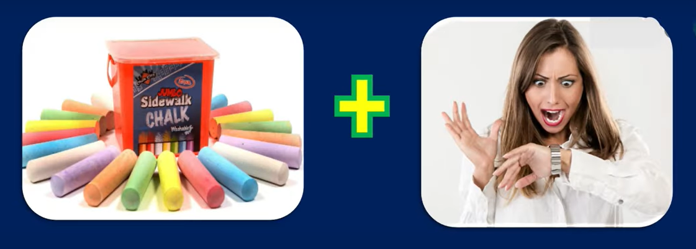  
  
  
  
  
  
  
  
  
  
  
  
  
  
  
  
  
  
  
  
  
  
  
  
  
  
  
  
  
  
  
  
  
  
  
  
  
  
  
  
  
  
12-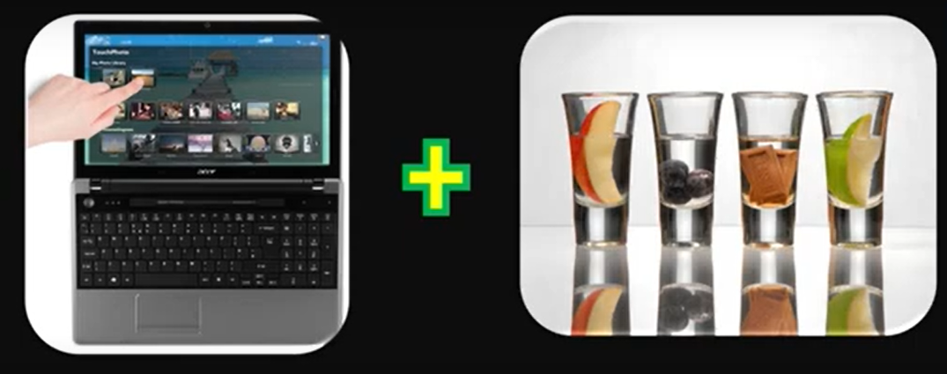  
  
  
  
  
  
  
  
  
  
  
  
  
  
  
  
  
  
  
  
  
  
  
  
  
  
  
  
  
  
  
  
  
  
  
  
  
13-  
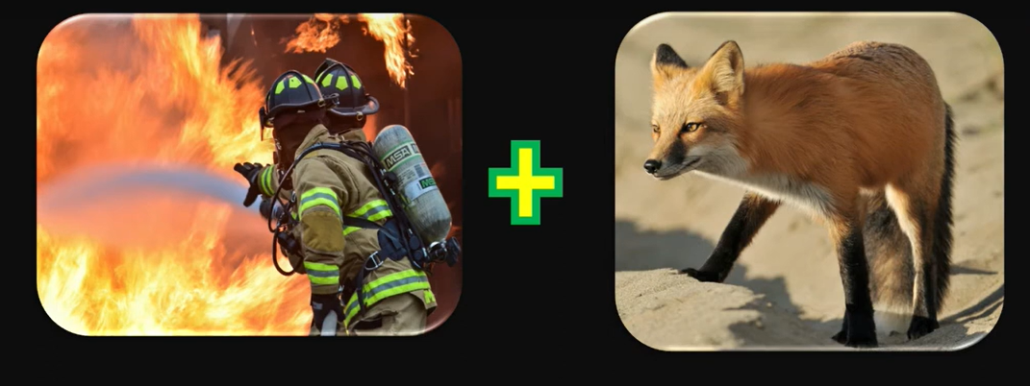  
  
  
  
  
  
  
  
  
  
  
  
  
  
  
  
  
  
  
  
  
  
  
  
  
  
  
  
  
  
  
  
  
  
  
  
  
  
14-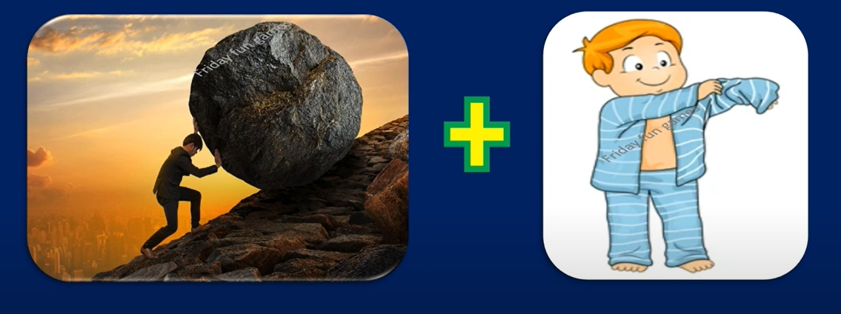  
  
  
  
  
  
  
  
  
  
  
  
  
  
  
  
  
  
  
  
  
  
  
  
  
  
  
  
  
  
  
  
  
  
  
  
  
  
  
  
15-  
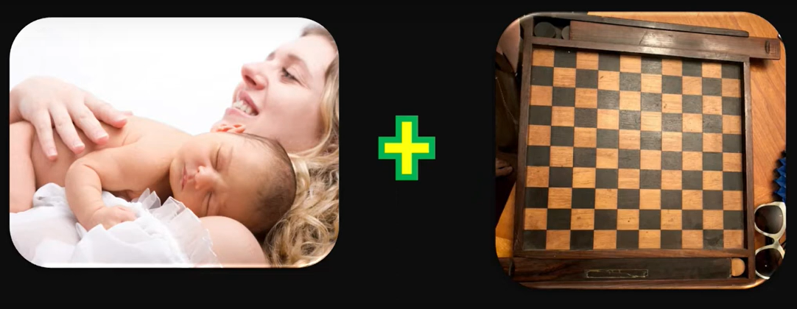  
  
  
  
  
  
  
  
  
  
  
  
  
  
  
  
  
  
  
  
  
  
  
  
  
  
  
  
  
  
  
  
  
  
  
  
  
  
  
16-  
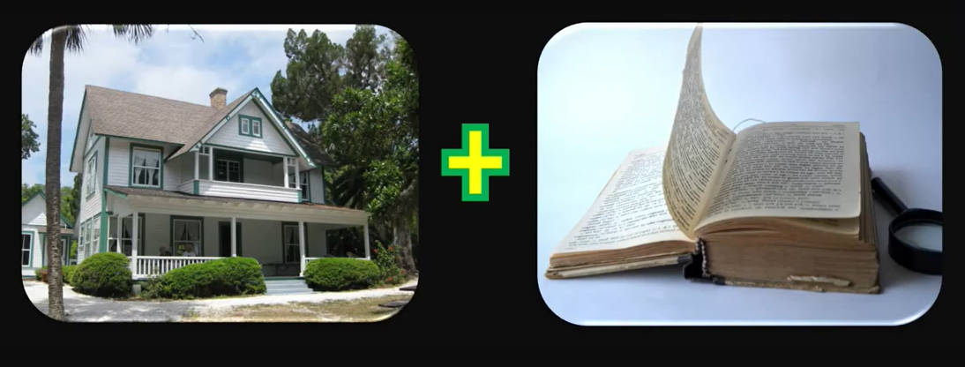  
  
  
  
  
  
  
  
  
  
  
  
  
  
  
  
  
  
  
  
  
  
  
  
  
  
  
  
  
  
  
  
  
  
  
  
  
  
  
  
  
  
  
  
  
  
  
  
  
  
  
  
  
  
  
  
  
  
  
  
  
 1- What’s your favorite way to spend a weekend?

1. If you could have dinner with any three people, dead or alive, who would they be?
2. What’s a new hobby you’ve picked up recently?
3. If you could travel anywhere in the world, where would you go?
4. What’s your favorite book or movie and why?
5. What’s the most interesting place you’ve ever visited?
6. If you could learn any skill instantly, what would it be?
7. What’s something you’re really passionate about?
8. What’s a memorable experience you’ve had with friends or family?
9. If you could switch lives with anyone for a day, who would it be and why?